📄 Project Documentation: Serverless Web App with S3, API Gateway, Lambda, and DynamoDB

🧭 Overview
Objective: Build and deploy a fully serverless web application using AWS services. The frontend is hosted on S3, while backend logic is handled by Lambda functions triggered via API Gateway. Data is stored and retrieved from DynamoDB.

🏗️ Architecture Summary
[Static Website on S3] → [API Gateway] → [AWS Lambda] → [DynamoDB]
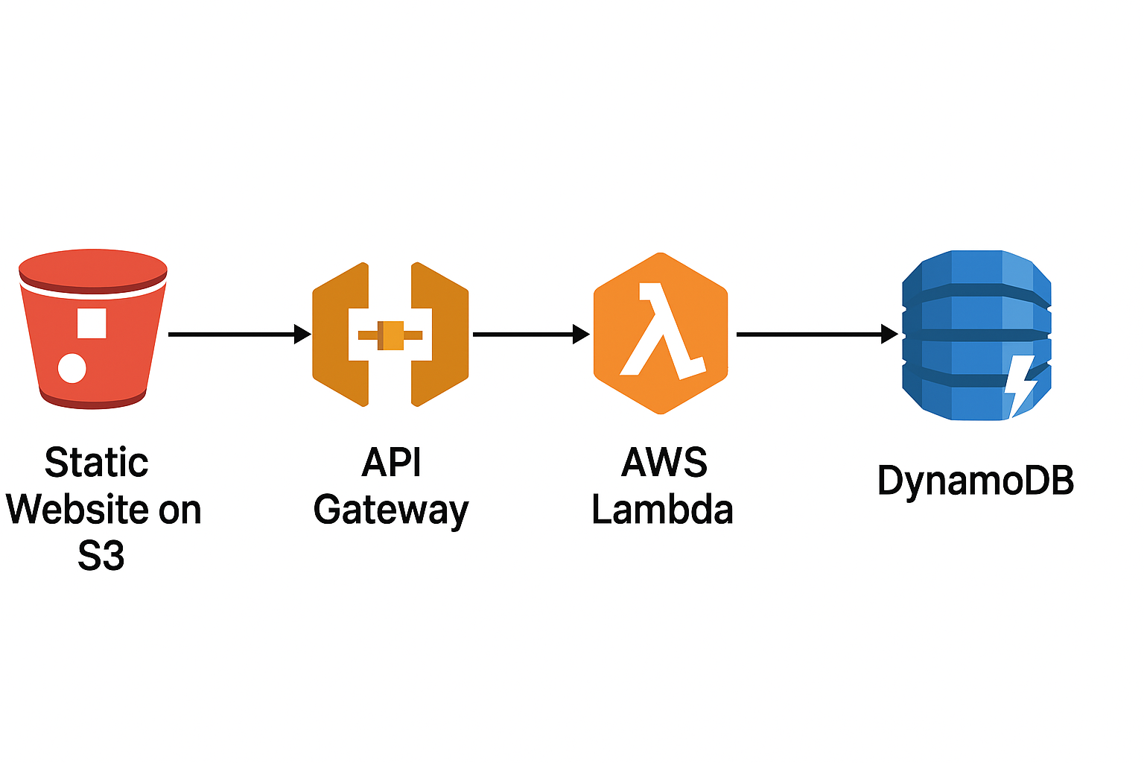
- Frontend: HTML/CSS/JS hosted on S3
- API Gateway: REST endpoints for GET and POST
- Lambda: Python functions for data access
- DynamoDB: NoSQL table for persistent storage

🔧 Step-by-Step Implementation

1. Hosting Static Website on S3
• Created an S3 bucket (e.g., my-web-app-bucket)
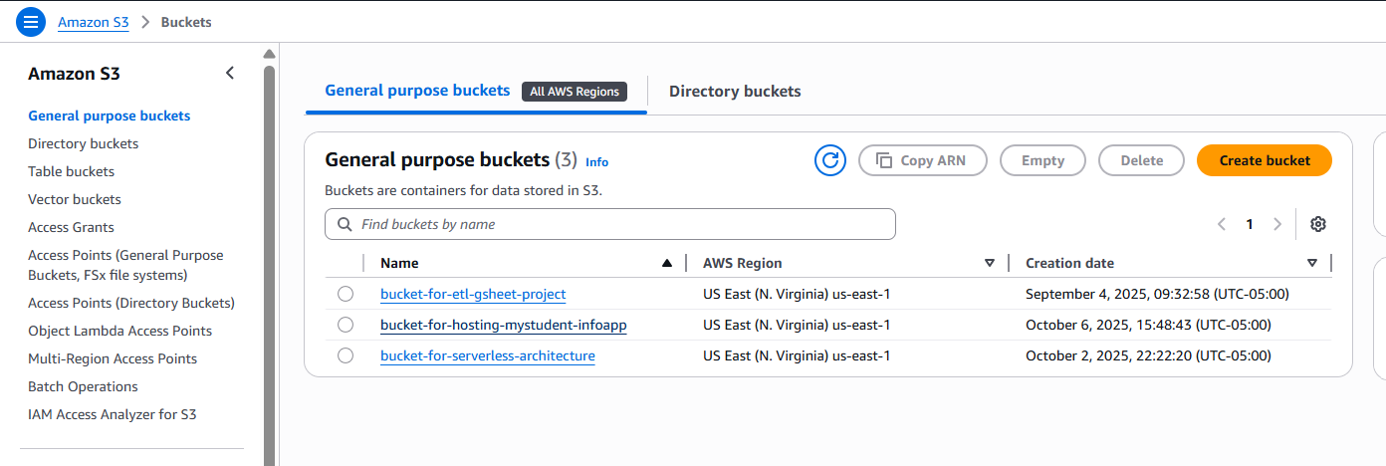
• Uploaded index.html and scripts.js
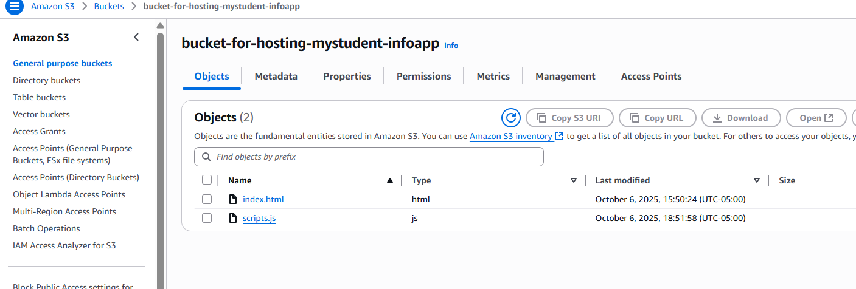

Scripts.js
// Add your API endpoint here
var API_ENDPOINT = "https://t2cutw78k4.execute-api.us-east-1.amazonaws.com/prod";

// AJAX POST request to save student data
document.getElementById("savestudent").onclick = function () {
var inputData = {
"studentid": $('#studentid').val(),
"name": $('#name').val(),
"class": $('#class').val(),
"age": $('#age').val()
};
$.ajax({
url: API_ENDPOINT,
type: 'POST',
data: JSON.stringify(inputData),
contentType: 'application/json; charset=utf-8',
success: function (response) {
document.getElementById("studentSaved").innerHTML = "Student Data Saved!";
},
error: function () {
alert("Error saving student data.");
}
});
}

// AJAX GET request to retrieve all students
document.getElementById("getstudents").onclick = function () {
$.ajax({
url: API_ENDPOINT,
type: 'GET',
contentType: 'application/json; charset=utf-8',
success: function (response) {
$('#studentTable tr').slice(1).remove();
jQuery.each(response, function (i, data) {
$("#studentTable").append("<tr> \
<td>" + data['studentid'] + "</td> \
<td>" + data['name'] + "</td> \
<td>" + data['class'] + "</td> \
<td>" + data['age'] + "</td> \
</tr>");
});
},
error: function () {
alert("Error retrieving student data.");
}
});
}

• Enabled Static Website Hosting under bucket properties
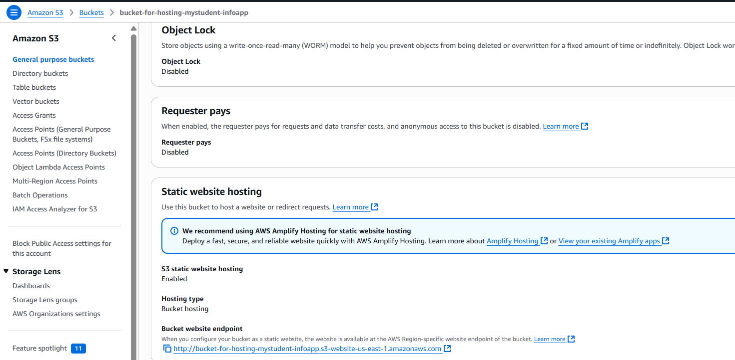
• Set bucket policy for public read access under Permission Tab:
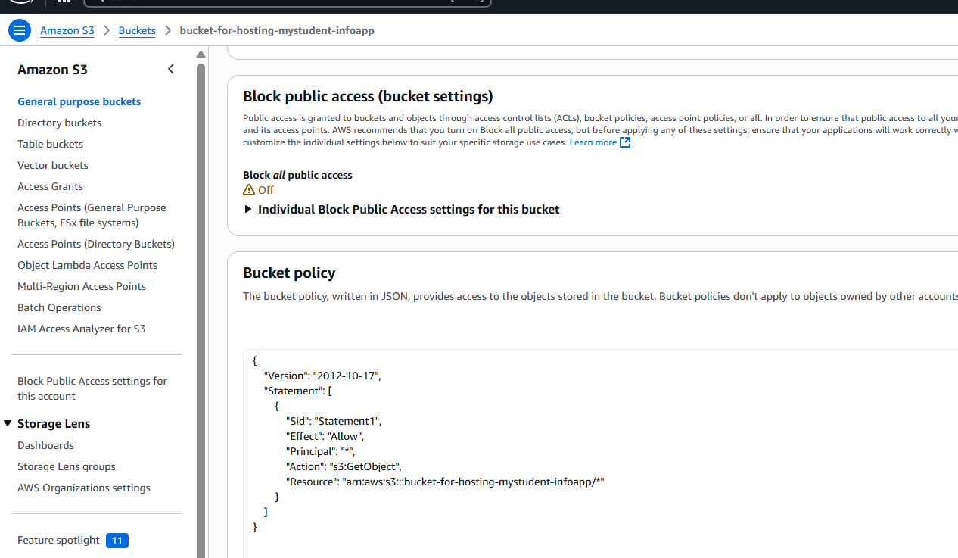
Policy:
{
"Effect": "Allow",
"Principal": "*",
"Action": "s3:GetObject",
"Resource": "arn:aws:s3:::my-web-app-bucket/*"
}
- If you successfully complete all these steps you will get access to the front end through the URL and my frontend UI looks like this
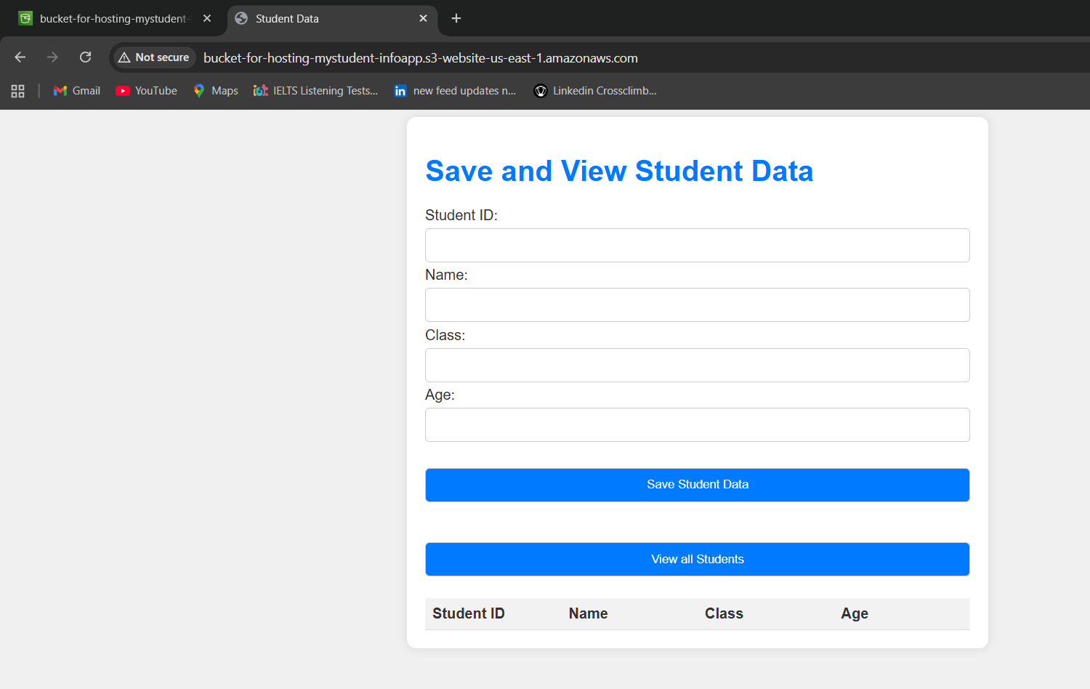

Configuring API Gateway

• Created a REST API in API Gateway
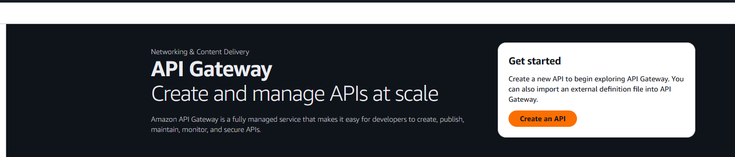

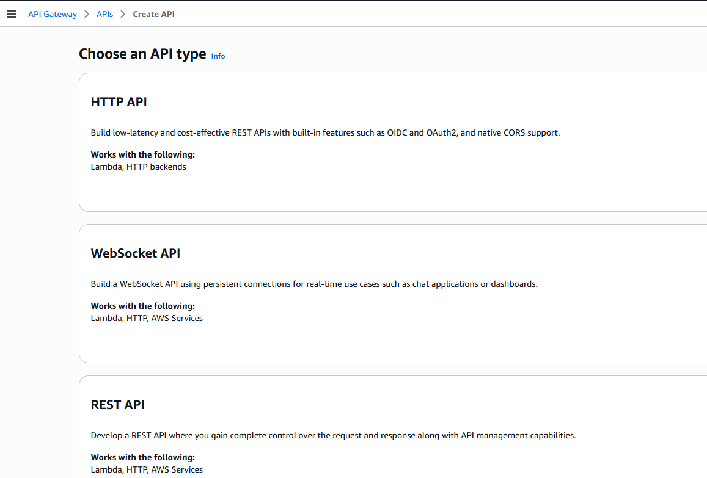

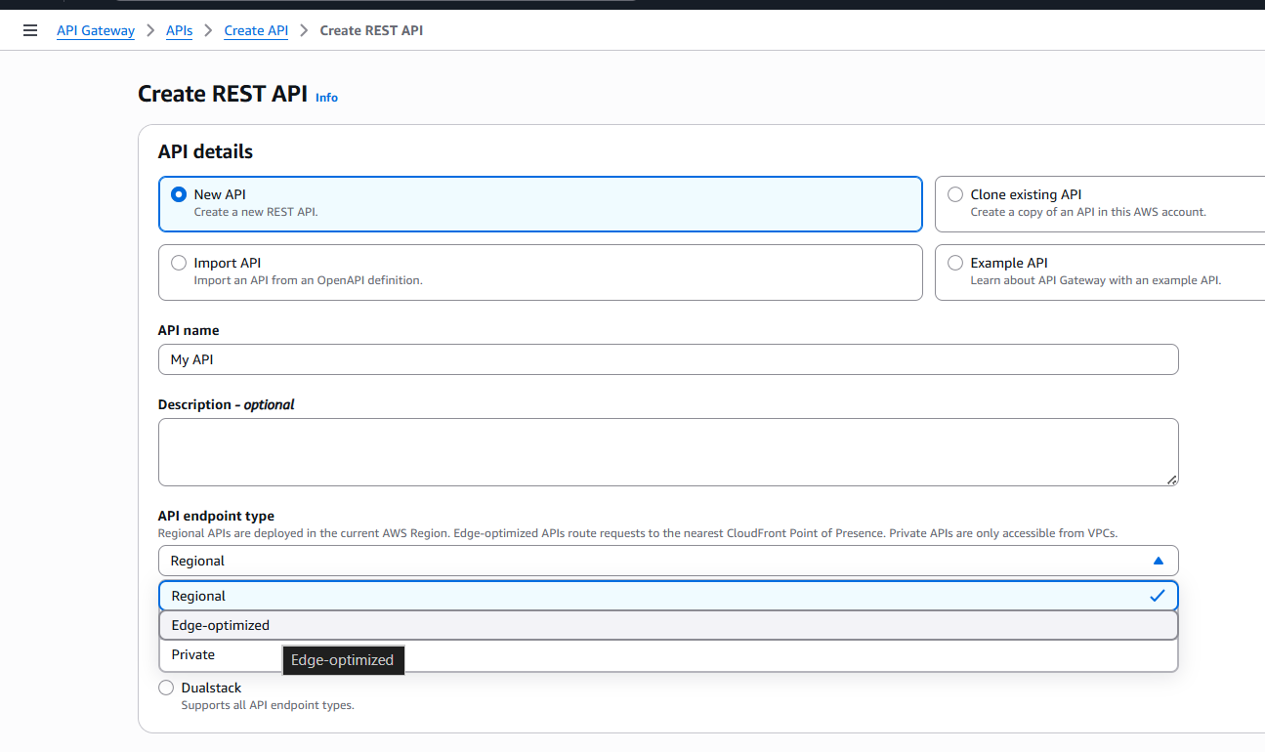

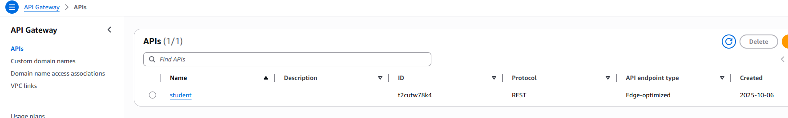
• Defined two endpoints:
- GET /items → fetch data from DynamoDB
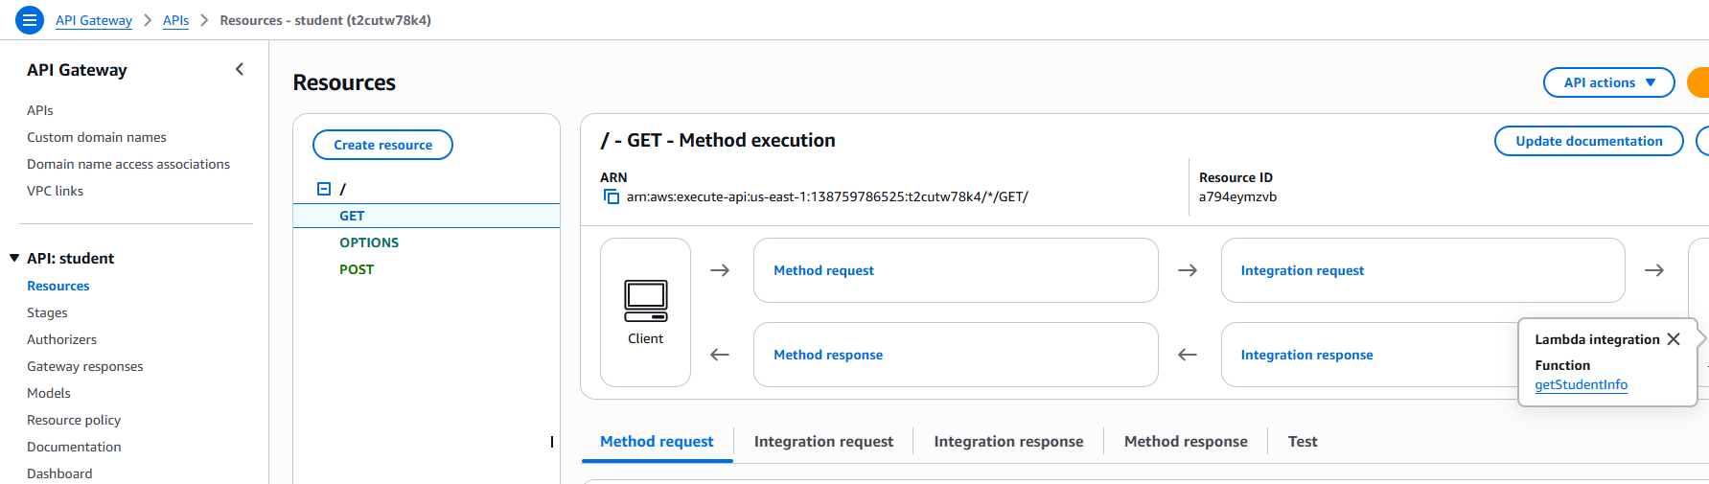
- POST /items → insert new data
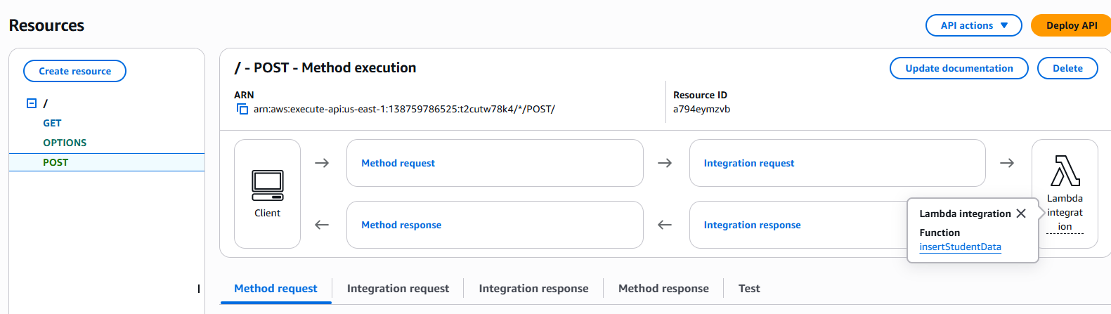
• Enabled CORS for frontend integration
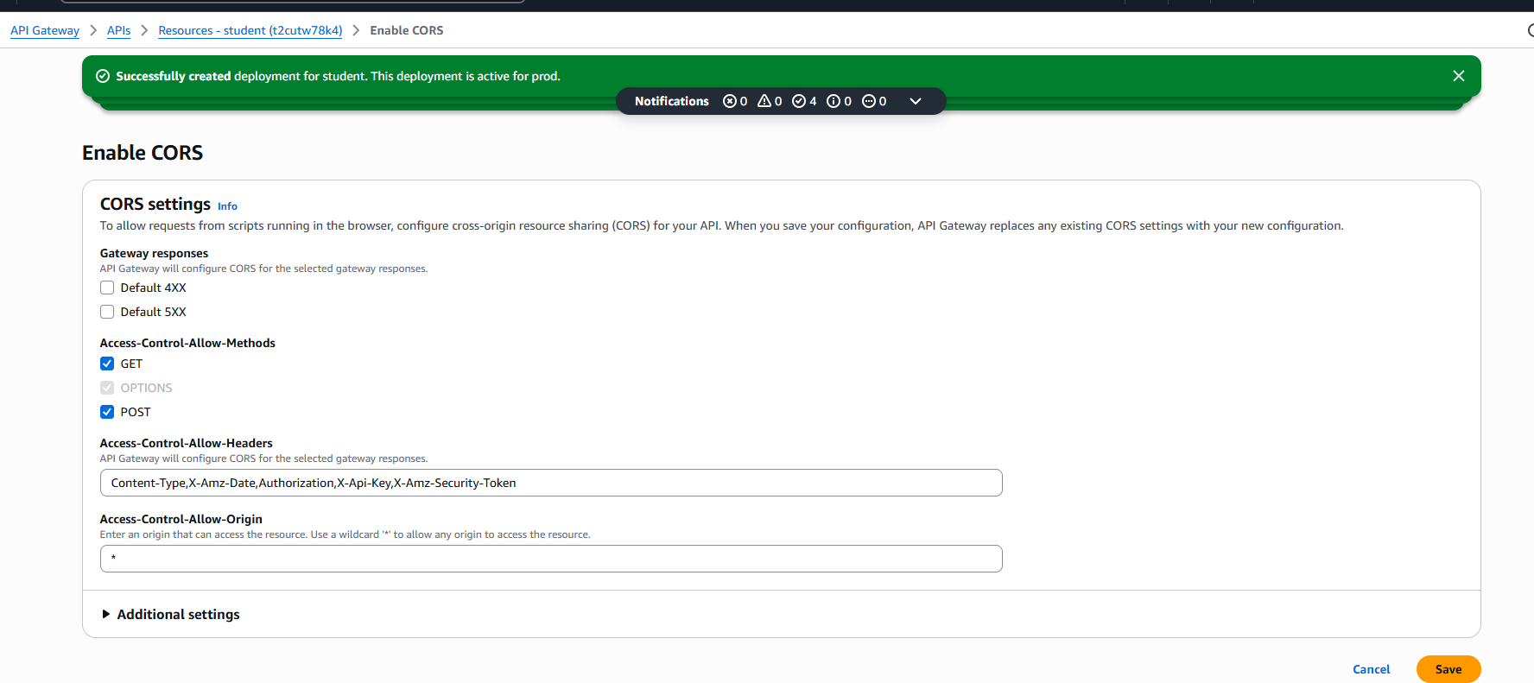
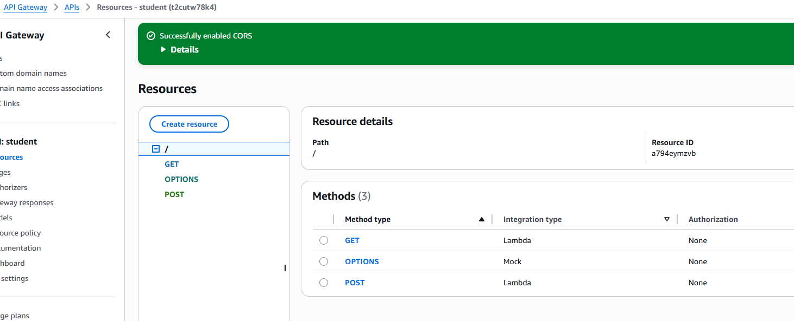
After deploying your API you will get an invoke URL like:
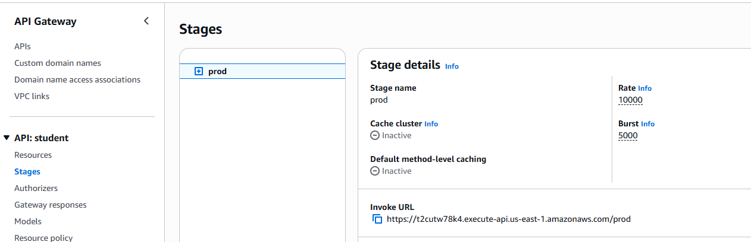
• Linked each method to its respective Lambda function
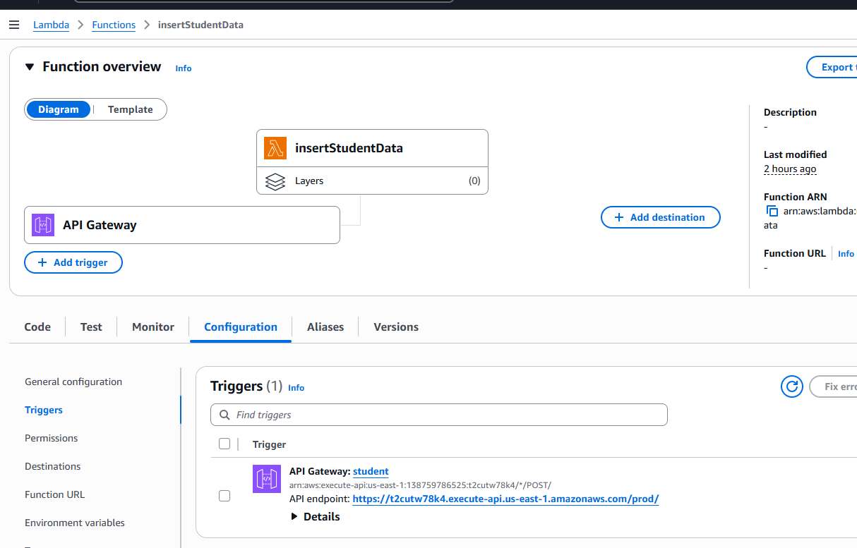

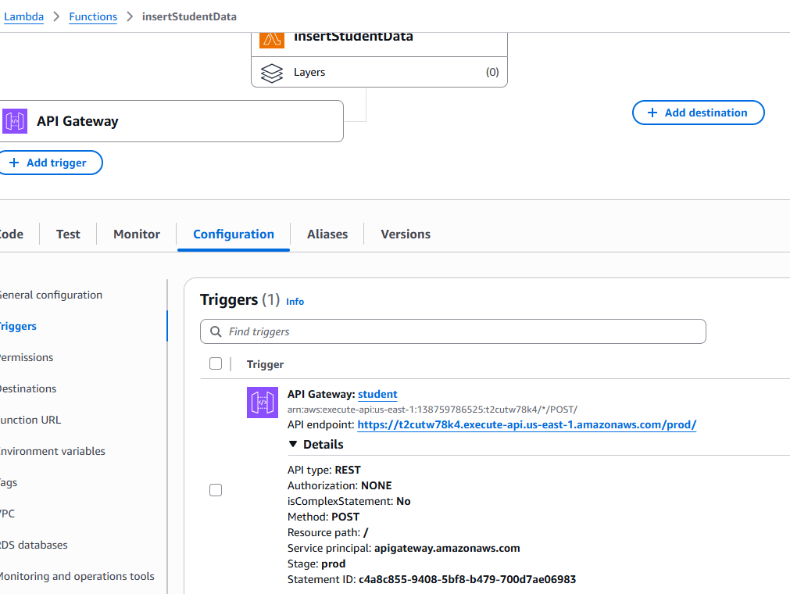

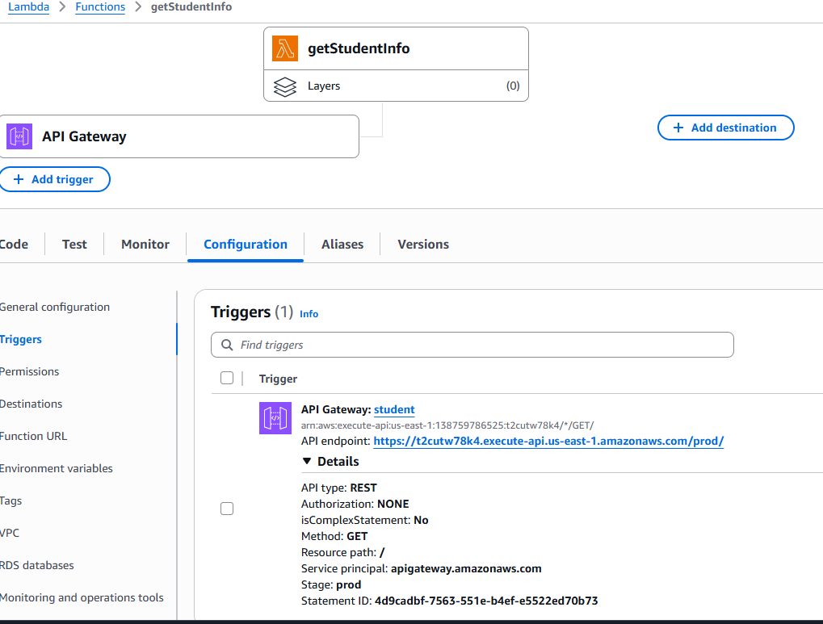

Creating Lambda Functions (Python)

insertStudentData.py:
Code for inserting data into DynamoDB
import json
import boto3

# Create a DynamoDB object using the AWS SDK
dynamodb = boto3.resource('dynamodb',region_name='us-east-1')
# Use the DynamoDB object to select our table
table = dynamodb.Table('studentData')

# Define the handler function that the Lambda service will use as an entry point
def lambda_handler(event, context):
# Extract values from the event object we got from the Lambda service and store in variables
student_id = event['studentid']
name = event['name']
student_class = event['class']
age = event['age']

# Write student data to the DynamoDB table and save the response in a variable
response = table.put_item(
Item={
'studentid': student_id,
'name': name,
'class': student_class,
'age': age
}
)

# Return a properly formatted JSON object
return {
'statusCode': 200,
'body': json.dumps('Student data saved successfully!')
}

getStudentInfo.py
Code for Retrieving data from DynamoDB
import json
import boto3

def lambda_handler(event, context):
# Initialize a DynamoDB resource object for the specified region
dynamodb = boto3.resource('dynamodb', region_name='us-east-1')

# Select the DynamoDB table named 'studentData'
table = dynamodb.Table('studentData')

# Scan the table to retrieve all items
response = table.scan()
data = response['Items']

# If there are more items to scan, continue scanning until all items are retrieved
while 'LastEvaluatedKey' in response:
response = table.scan(ExclusiveStartKey=response['LastEvaluatedKey'])
data.extend(response['Items'])

# Return the retrieved data
return data

4. Setting Up DynamoDB
• Created table Items
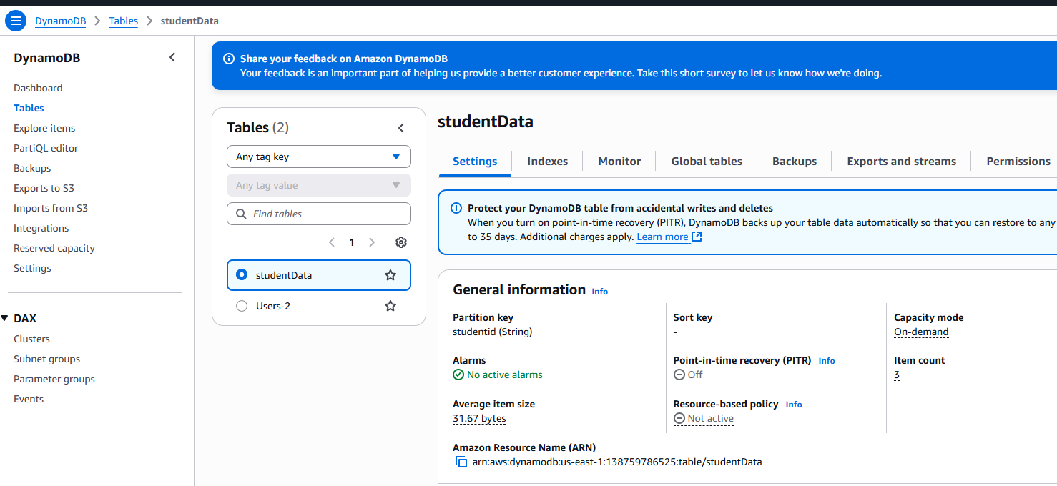
• Partition Key: studentid (String)
• Additional attributes: name, class,age
• Enabled on-demand capacity for simplicity
• Verified CRUD operations via Lambda and API Gateway
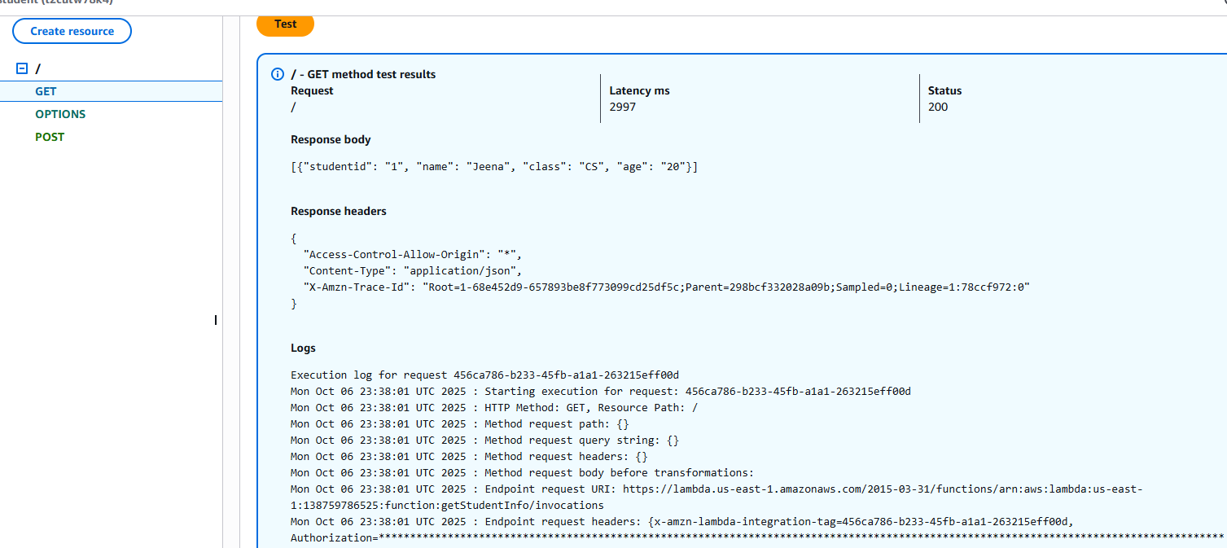

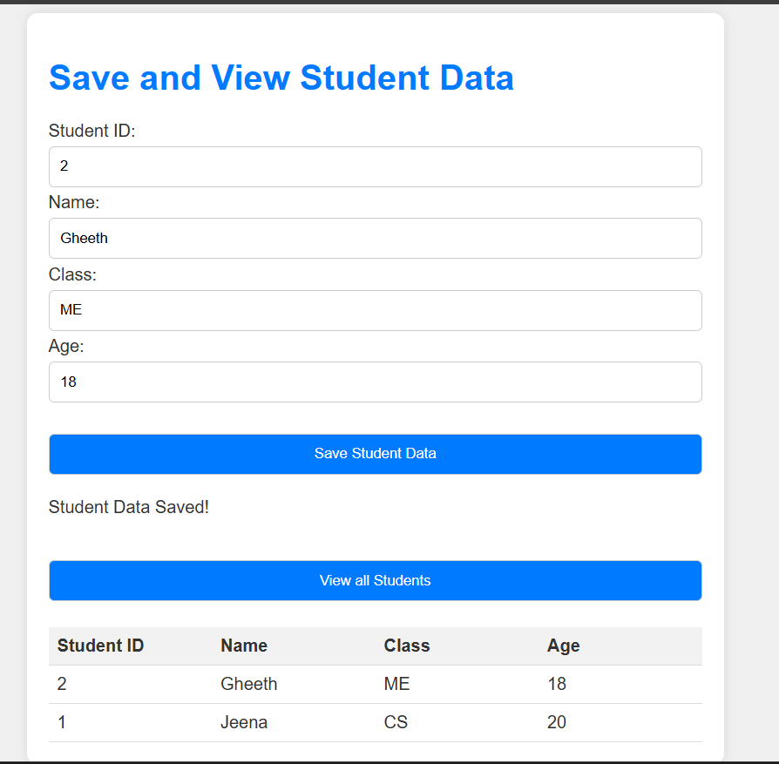
All the items will get iserted into DynamoDB table
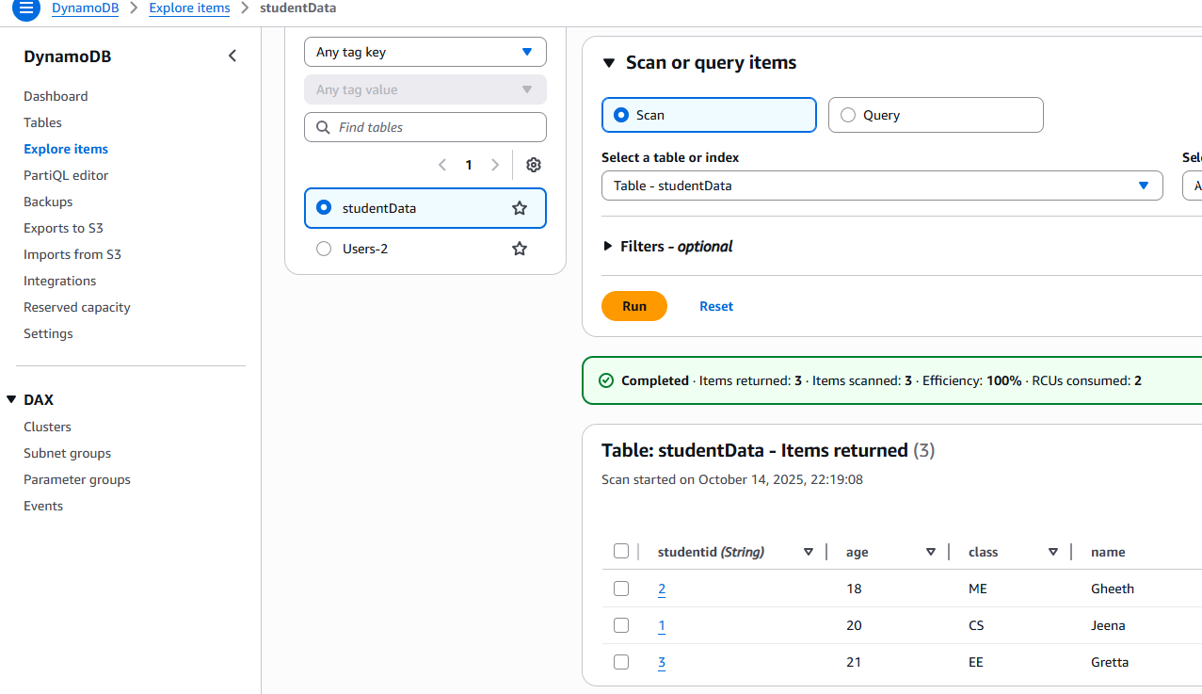

📁 Deliverables
Component | Description
S3 Bucket | Hosts static frontend files
API Gateway | Routes HTTP requests to Lambda functions
Lambda Functions | Python code for GET and POST operations
DynamoDB Table | Stores application data
Architecture Diagram | Visual flow of components
Documentation | This file, suitable for recruiters or teams

✨ Highlights
• Fully serverless architecture—no EC2 or manual provisioning
• Clean separation of frontend and backend logic
• Scalable and cost-efficient using AWS native services
• Demonstrates real-world integration of S3, API Gateway, Lambda, and DynamoDB

